Resources for Friday Labyrinth Walk - March 18, 2022
Twylla Alexander

Quotes placed around the labyrinth at Mercy Center, Burlingame , CA

–Hope is the refusal to accept or confirm the closer world of despair.

–Hope is a feeling of empowerment, a sense of purpose that is collaborative and focused on a higher goal.

–Hope is reality based and active… a strength or power that is developed.

–Don’t ever underestimate the importance you can have because history has shown us that courage can be contagious and hope can take on a life of its own. - Michelle Obama

Quote by Jane Goodall

“Hope is action.”

Her most recent book, The Book of Hope: A Survival Guide for Trying Times

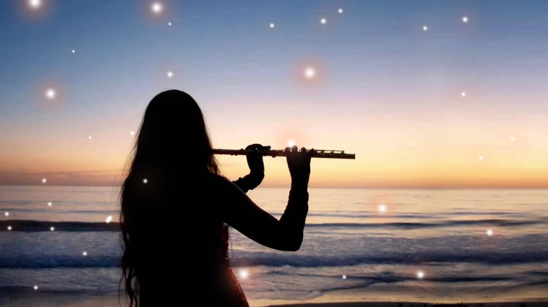
Music - Piano and Flute by Dean Evenson and Tom Barabas from the album WINDDANCER.
1st stanza of “Hope” poem by Emily Dickinson:

“Hope” is the thing with feathers -
That perches in the soul -
And sings the tune without the words -
And never stops - at all -

