Imbolc BY CAROLINE MELLOR
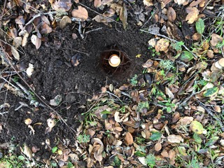
I am the dream of awakening.
I am the returning of the light.
I am the tough green shoot pushing up through the pavestones, I am the first kiss of sunlight on the unfurling petals of the snowdrop. I am the wind which whispers the gentle pull of home to the migratory bird.
I am the drop of ice melting on the mountainside with its great dream of the ocean.
I am the sap rising in the blossom tree just before it reveals its sticky buds to the sky; I am the riotous celebration humming away beneath the earth’s mantle of frozen sleep.
I am the rousing of the bee from its winter slumber, and the soft pad of the mother-wolf’s paw on the snow as she prepares to birth her pups.
I am hope, potential, rebirth and promise. I am the kindling breath which transforms the flicker of inspiration in your creative core into a blazing torch.
Give me the silent crescent moon rising over the sea and I will build you a bridge of silver light so you can walk up and lie in it.
Give me the frost-hardened wilderness and I will breathe radiant green life over it.

