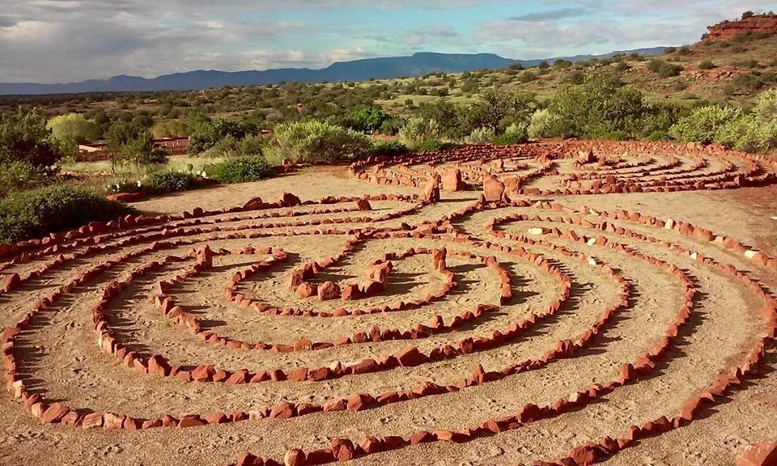
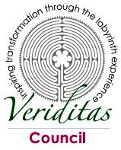
Initial Creation of Veriditas Council:
The Evolution of VeriditasCouncil
Collaborative in-depth work of three committees ignited the direction, purpose and vision of what became the Veriditas Council:
- Organizational Identity Committee
- Clarified Veriditas’ mission in the world, core values and unique gifts.
- Determined that Council goal was to better understand who we are and what we bring to the transformation of the human spirit.
- Programs and Workshops Committee
- From evaluated programs offered by individuals representing Veriditas, Committee determined that the value of enhanced programs in specific topic areas, such as hospitals, prisons, and schools, would better feed the Veriditas mission.
- Considered ways to create alliances with organizations working on compatible and complementary issues.
- Facilitator Training Committee
- Created a structural timeline and processes for application, training and curricula for facilitators to become teachers to “Train-the-Trainers,” shifting some training responsibilities from Lauren Artress to others through this special training.
Founding & EARLY members: Margie Adam, Lauren Artress, Kay Buxton, Cindy Cleary, Janet Cooper, Aimee Dominique, Catlyn Fendler, Tracy Friedl, Martha Griesinger, Paula Hendricks, Kathy Knight, Marge McCarthy, JoAnn Mast, Ellen Meuch, Kay Mutert, Melissa Postnikoff, Lisa Steckley, Judith Tripp, Craig Wirth, Jane Wirth.
Evolved Council Vision, Mission and Goals
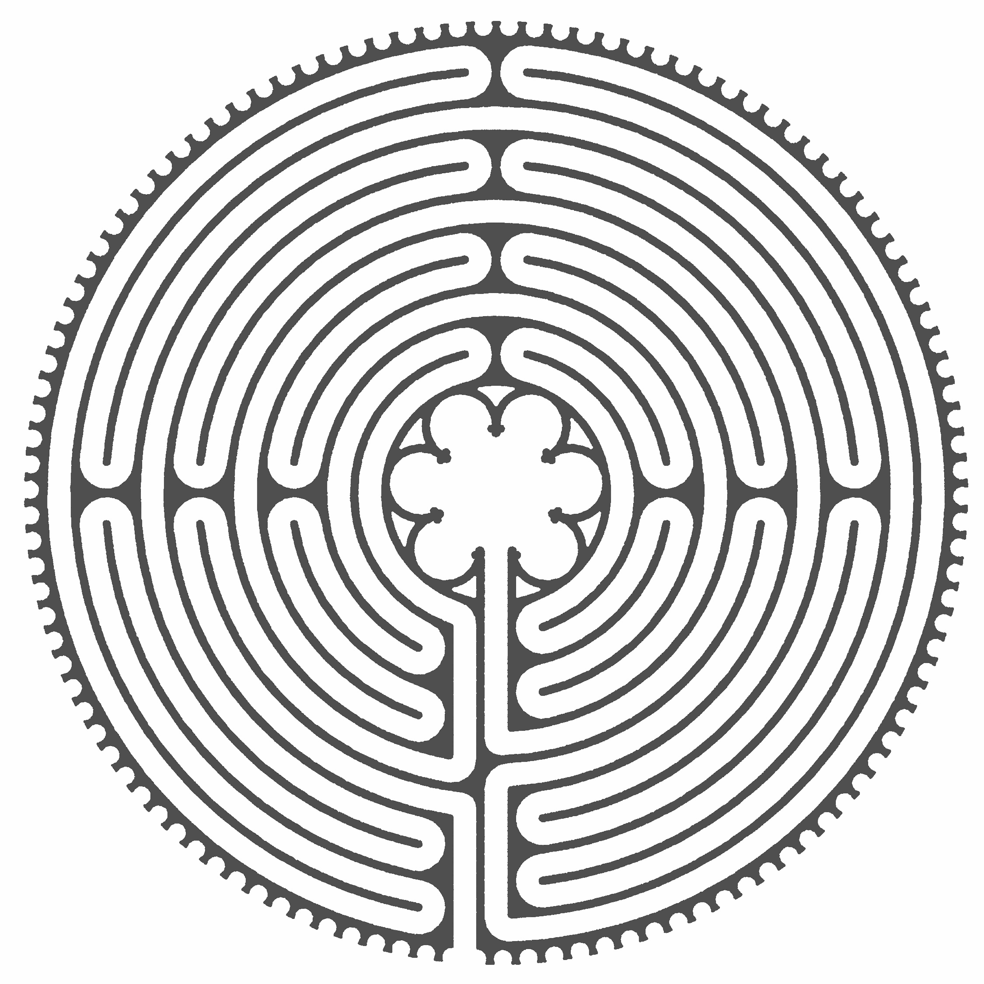
Vision: to serve as the voice of Veriditas facilitators worldwide.
2004
2005-12
Mission: to support the vision and work of Veriditas working in cooperation with the Veriditas Board and Regional Facilitator Network.
We are the Council, visionary incubators of new ideas for Veriditas. We are task-oriented workers, making connections, instituting programs, being ambassadors for the mission of Veriditas. We work in circle creating ritual to bring us all present to create the ‘highest good.’
Goals:
- To build connections within the network of trained facilitators worldwide;
  - Create community and connection through the framework of the small-Circle concept;
  - To promote ideas and programs;
  - Pilot new ideas or programs to determine their viability as suggested or approved by the Board.
Created Global Healing Response (GHR)
  - Designed by Council member Ellen Bintz Meuch after witnessing the work of Veriditas facilitators following September 11, 2001, and the Water Labyrinth
Project following the December 2004, Tsunami in Asia; initiated August 8, 2005, three weeks before Hurricane Katrina.
  - GHR uses the labyrinth in a unified response to promote stress management, grief integration, and healing in circumstances of emergency or disaster.
  - GHR provides a themed quarterly resource for the labyrinth community to gather and provide unified healing. See: http://www.globalhealingresponse.com/ for details on annual themes such as A Call for Courage, Unity, Gratitude,
& Stability.
  - Kinship is healing; we are physicians to each other. ~ Oliver Sachs
Became the Voice of the Facilitators
- Initiated Regional Representatives for eight separate regions, collaborating with other labyrinth events; later implemented a Veriditas Regional Rep Survey as follow-up to the Rep job description
- Developed support and communications processes to reignite facilitator international network.
- Offered codified small-circle concept for regional gatherings and workshop discussions at Chartres.
Established Programs & Projects
- Initiated the Annual Veriditas Auction.
- Created the Facilitator Starter Kit.
- Recommended Facilitator Specialists to deepen the experience of the labyrinth and broaden the impact of Veriditas in the world in specialty fields like: prisons, hospitals, schools, mental health centers, and Hospice.
- Initiated the Melissa Postnikoff Scholarship Fund: seeded through a fund-raising labyrinth walk in Denver Colorado, facilitated by Lauren Artress, and held on the beautiful Palazzo Verde indoor marble and stone labyrinth.
Initiated Regional Facilitator Luncheons
- 2011: First semi-annual Regional Council Meeting & Facilitator Luncheon was held in Alabama; ideas exchanged; labyrinth walked in community.
2013-20
- November Council and Facilitator Gathering held in Colorado; Board members Chris Katzenmeyer and Lee Matthew joined the meeting.
- Council and Facilitator meetings held later in Houston, Texas, and in Portland, Oregon, with facilitators and Board President, Gary Peterson, and Board Members Phyllis Carlisle and Mary Jo Saavedra.
Developed Facilitator Mentoring Program
- Conceived by Master Teacher Kay Mutert; implemented at her Charlotte, North Carolina, facilitator training.
- Introduced to facilitator trainings in Portland, Oregon, and Way Cross, Indiana, by Master Teacher, Jo Ann Mast.
- These Council members also review all certification applications.
Reworked Council Mission, Vision and Guidelines www.veriditas.org/council
Continued Council/Facilitator Gatherings
- Board member, Phyllis Carlisle, joined the Santa Fe, New Mexico, gathering;
- New York City Council gathering welcomed facilitators for lunch and labyrinth walk.
- Sponsored luncheon for Chicago area facilitators.
Prepared & hosted VERIDITAS ANNUAL Community Gatherings (2013, 2014) in Petaluma, California, for facilitators & labyrinth friends.
- Held Scholarship Silent Auction with items supplied by Council members.
  - Initiated topics focusing on council and facilitator labyrinth work from around the world.
Created Veriditas International Association of Trained Facilitators (VIA) (2016) to promote professionalism within the community of trained facilitators.
Initiated Renewal Days to gather and support trained facilitators in different geographic areas each year
- Santa Fe, New Mexico (2015). First full-day renewal workshop gathering for trained facilitators.
- Renewal Day Ottawa, Ontario, Canada (2016).
- Renewal Day at Stony Point Center, Stony Point, New York (2018). Hosted facilitators with a format of varied short programs. The day’s beginning and ending labyrinth walks coalesced the group.
- Subsequent to Renewal Day, Stony Point Center worked with Nathan Wiles to refurbish their labyrinth.
- Renewal Day Solomon Center, Loranger, Louisiana (2019). Veriditas board president, Kathe Rhinesmith, greeted the 20+ facilitators from 19 states. Judith Tripp served as Emcee. Local facilitator, Annelle Tanner, guided the opening ritual walk with wisdom on the importance of water and the symbolism of the frog to Louisiana. Successful elements included the Friday evening themed walk followed by a slide show, short interactive presentations, & vendors who donated proceeds to the scholarship fund. Subsequently, Solomon Center worked with Calen Rayne & Nathan Wiles to create an on-site labyrinth.
MEMBERSHIP:
- Welcomed new Council members Linda Mikell, (2008), Chris Farrow-Noble, (2012), and Paul Campbell, (2013).
- Supported Judith Tripp as Council representative on the Board.
- Promoted Linda Mikell’s Little Miracles on the Path book for scholarship fund for labyrinth facilitators in training (2016).
- Produced Welcome Cards (with Quick-Reference insert) for Council to distribute to newly trained facilitators.
- Reevaluated Regional Rep Program to consider more efficient ways to communicate with facilitators (2017).
- Honored retiring Council Members Kay Mutert, Ellen Bintz-Meuch, Grace Amirault and JoAnn Mast (2018), plus founding member, Judith Tripp, and members, Laura Esculcas, Linda Mikell, and Calen Rayne (2019).
- Welcomed new Council members: Tina Christensen, Karen Kelley, Marion Patterson, & Calen Rayne (2018).
- Welcomed new Council members Twylla Alexander, Christine Favreau, Barrie Gibby, and Mary Ann Wamhoff (2019). Pairing new members with a mentor eased the transition to Council.
- Karen Kelley became the new Council representative to the Veriditas Board. (2019).
- Welcomed new Council members Michel Le Gribble-Dates, Nathan Wiles, & Betty Lopez-Towey (2020).
- Honored retiring members, Chris Farrow-Noble and Kathryn McLean, (2020).
Updated the Council website page.
Organized documents related to succession and Council Roles.
Created organizational documents to delineate Council responsibilities & tasks.
Began planning Renewal Day 2020, reaching into new territory in the Black Hills and offering a concurrent Qualifying Workshop. These events were cancelled due to the Pandemic Coronavirus that swept the globe winter 2020.
HELD THE CIRCLE for all suffering from the Pandemic.
REVISITED AND MADE CHANGES TO the Vision and Mission Statements.
ORGANIZED FACILITATOR WELCOMING COMMITTEE to contact newly trained labyrinth facilitators.
DELINEATED JOB DESCRIPTION for the committee.

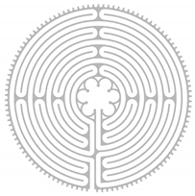
MEMBERSHIP:
- Welcomed new Council members Chuck Hunner, Dhyana Raynor, Karen Price, Leslie Wright, Vicki Longhofer, and Peter Valles (2021). Pairing new members with a mentor eased the transition to Council.
- Honored retiring Council members Twylla Alexander, who stepped into Veriditas Board Presidency, and Paul Campbell, Christine Favreau, Nathan Wiles, Betty Lopez-Towey and Tina Christensen.
- Welcoming new facilitators with a congratulatory letter and information on Veriditas initiatives and programs has proved to be a valuable way to connect members and encourage participation.
PANDEMIC INITIATIVES:
2021-2023
22022
- The Inaugural Virtual Facilitator Renewal Day (VFRD) conducted on ZOOM in January 2021 reached close to 90 participants spanning the globe. The theme “Sculpting New Practices” was enthusiastically received.
- The theme for July 2021 Veriditas Council led VFRD#2 continued to engage over 60 participants from three continents as they explored “Creating Compassionate Journeys with Earth, Air, Fire and Water.”
- Council continued the success with VFRD#3 in January 2022 as 90+ participants delved into the theme “Ritual Groundings of Holding Space.”
- Responding to Labyrinth enthusiasts desire for more chances to simply visit on topics of interest to them, Council initiated two MeetUps! in 2022. (June & October) These free, hour-long programs allow facilitators to exchange ideas and support each other in small break-out rooms.
- Council members also participate monthly with staff in the weekly Friday Finger Labyrinth Walks presenting engaging themes and allowing the space for facilitators to reflect and share.
- Council’s VFRD#4 in January 2023, focused on Return to Our Roots”. The Rev. Lauren Artress bookended the day by sharing the background of her seminal books, Walking a Sacred Path and The Sacred Path Companion and guiding a finger labyrinth walk. Twelve facilitators engaged approximately80 participants in sharing circles as they interacted on the themes.

