Resources for December 1, 2023 Handheld Finger Labyrinth Walk
with Judith Tripp and Ruth Cunningham on the theme:
"On the Brink of Advent - exploring the inner spiral of the year."

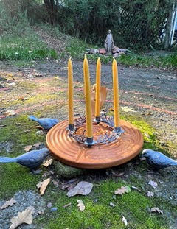

Advent Poem by Jessica Powers

I live my Advent in the womb of Mary.
And on one night when a great star swings free
from its high mooring and walks down the sky
to be the dot above the Christus i,
I shall be born of her by blessed grace.
I wait in Mary-darkness, faith's walled place,
with hope's expectance of nativity.
I knew for long she carried me and fed me,
guarded and loved me, though I could not see.
But only now, with inward jubilee,
I come upon earth's most amazing knowledge:
someone is hidden in this dark with me.

