The Labyrinth as a Symbol of Wholeness
Veriditas Online Finger Labyrinth Meditation
July 24, 2020
Facilitated by Brighid FitzGibbon

Musical Selection:

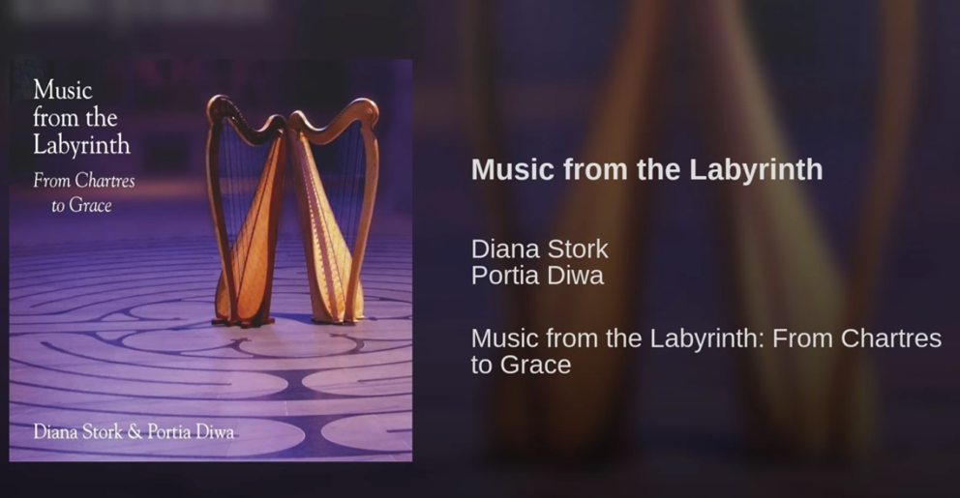

Opening Quote:

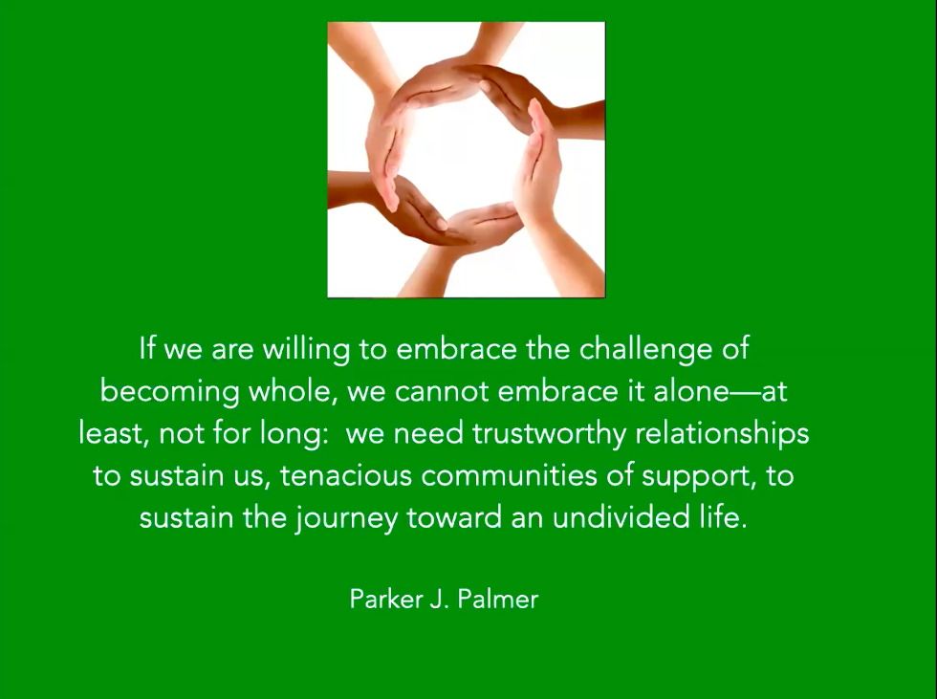

Closing Quote:

